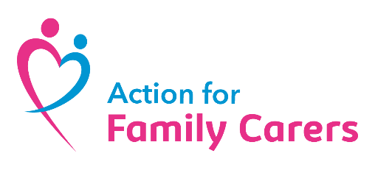
Sponsorship form
Your donation will make a positive impact on the lives of unpaid carers
£10 helps cover the cost of a phone call to a carer who’s feeling isolated
£15 gives a carer an hour with a dedicated Young Carers Support Worker.
£50 pays for food and activities at a Young Carers Respite Club.

What I’m doing and why I’m doing it

Fundraiser details
First Name*: ……………………………………….. Surname*: …………………………….

Address: …………………………………………………………………………………………………….

Postcode*: …………………………….. Daytime Telephone: ……………………………………..

Email address:…………………………………………………………………………………………….

I have enclosed a total of £…………………………………… Date……………………………..

PLEASE SEND YOUR COMPLETED FORM TO:
Please scan and email your completed forms to info@affc.org.uk or post to Action for Family Carers, Brickhouse Farm, Poulton Close, Maldon, CM9 6NG.
Make cheques payable to Action for Family Carers.
Please don’t send cash in the post.

Sponsorship form

For every £1 donated by UK Taxpayers we can claim an extra 25p from the Government – and it doesn’t cost you a penny! Just make sure your donors provide their full name and home address and tick the Gift Aid box. See box below for qualifying details.
Full name | Home address | Postcode | Gift aid? | Sponsor amount | Date collected
Mr Joe Bloggs | My house, my street, my town | CM9 6NG |  | £15 | 01/01/2025
* If I have ticked the box headed ‘Gift Aid my donation’, I confirm that I am a UK Income or Capital Gains taxpayer. I have read this statement and want Action for Family Carers to reclaim tax on the donation detailed below, given on the date shown. I understand that if I pay less Income Tax/or Capital Gains Tax than the amount of Gift Aid claimed on all of my donations to charities and CASCs in the current tax year it is my responsibility to pay any difference. I understand the charity will reclaim 25p on every £1 that I have given.

